AP CSP Python with CodeX  From Code to Flowcharts Activity Guide |  |  |  |  |  | Name:
Review : Flowchart Symbols Give a brief summary of what each flowchart shape is used for.
Activity : From Code to Flowcharts Create a flowchart for each Python program.
Python Code #1.

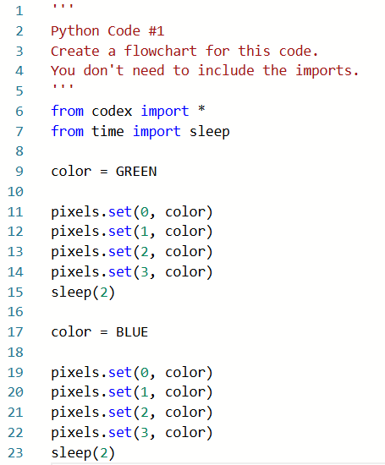

Python Code #2
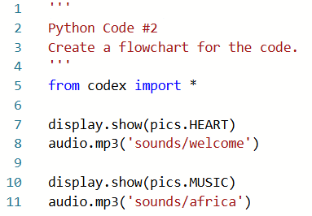

Python Code #3
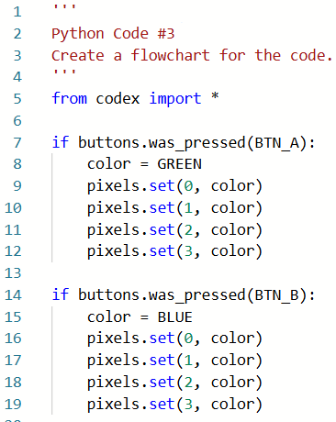

Python Code #4

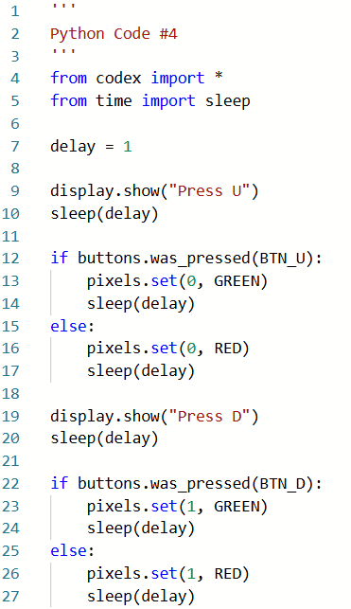

Challenge: Create your own flowchart from the Python code.
